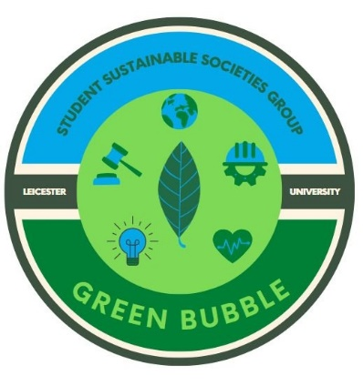**Green Bubble Agenda**

Meeting held on January 23rd at 17:30 – 19:00   
in the Boardroom in the Percy Gee building

1. Students’ Union Updates
2. Social Impact Team Updates
3. Volunteering Talk
4. Societies & Student Updates
5. Break
6. Go Green Week idea sharing:

|  |  |  |  |  |  |
| --- | --- | --- | --- | --- | --- |
| Feb | 13 | 14 | 15 | 16 | 17 |
| Go Green Week! | Sustainability “101” Talk    Plant sale | Litter pick    Film night (David Attenborough documentary?) | Litter pick    Potentially a launch of E-cigarette recycling disposal in Letsdisko | Upcycle workshop    Fashion swap | Cooking class |

Additional points:

* SU Funded Carbon Literacy Training
* Discounts at NADA
* Debate Society hosting a Sustainability related discussion with Academics
* Anything you guys want to do!

1. Open discussion/Any other Business?

Next Meeting Date:

**Monday February 27th at 17:30-19:00 [Dates may change]**