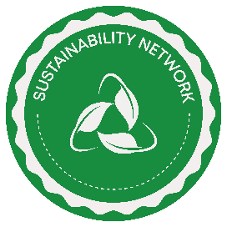 Leicester Students’ Union Sustainability Network

Sustainability Hub Resources



**Go green for lazy people ideas:**

* Turn off water tap when brushing teeth
* Use / bring a reusable water bottle
* Unplug your electronics at night
* Use / bring a reusable bag to the shops
* Wash your laundry in cold water
* Hang your washing out to dry
* Avoid food waste
* Lower the temperature of your heater
* Reduce, Reuse and Recycle
* Use cloth napkins instead of paper
* Watch documentaries about the food industry and environment
* Donate clothes / shop at thrift stores = sustainable fashion
* Walk, bike or use public transportation
* Reduce meat and dairy consumption
* Avoid single use plastics
* Support sustainable brands
* Drive the speed limit
* Go paperless / pay your bills online
* Avoid using generative AI tools like ChatGPT

**Green washing and eco-myths ideas:**

* Eco-friendly cleaning isn’t as effective
* Green cleaning products are more expensive
* All eco labels are not created equal