How to start a New Student Group (Society/Club) guide 25.26

Contents

1. Introduction 3

2. Disclaimer 3

3. New Student Group Criteria 4

4. How to apply 4

5. Timeline 5

6. Societies Council 6

7. Available Support – Students’ Union Activities Team 6

8. Available Support – Academic Reps and School Departments 6

9. Additional Information 6

10. How can we get in touch? 7

Change Log 7

## Introduction

Student Groups are a great way to build friendships with students, learn a new skill, connect with students from the same nationality, culture, faith and build skills that will be useful for your working life! We aim support students as much as possible to help them start a New Student Group and have developed this handbook to guide students through the New Student Group application process.

A Student Group, which is also referred to as a Society or Club, is a group where students can meet and have the opportunity to complete activities and attend events based on hobbies, sports, academic courses, community action, faith, nationality and culture, music, performances and many more. We will be using the term ‘Student Group’ throughout this handbook. A student may find that there is not a current student group that exists in their interested area so they may wish to start a New Student Group.

A New Student Group can be a Student Group that has never existed before or re-starting a Student Group that hasn’t been active in the current academic year. You may hear the phrase ‘adopting a Student Group’ which is the same as re-starting a Student Group.

The students who run and organise a Student Group are referred to as the Committee of that Student Group. A Student Group must have the three core positions filled to be officially affiliated with the University of Leicester Students’ Union. These three core positions are President, Treasurer and Wellbeing & Inclusion Ambassador. The three core positions must be fulfilled by three different students who currently attend the University of Leicester. You can also add non-core positions to your Student Group such as Secretary if you wish to do so.

It is important that you read through this handbook carefully, and get in touch if you have any questions. You should also read through the example applications before starting to fill out your own application. Please note that we may require you to attend a meeting to discuss your application before it’s considered by Societies Council. This will help make your application as strong as possible, and maximise the chances of your New Student Group application being approved.

## Disclaimer

Whilst we endeavour to support students to start a New Student Group, please note that an application submitted to start a New Student Group does not guarantee with certainty that the application will be approved.

If a similar New Student Group application was approved before in the past; this does not guarantee your application will be approved.

Zero abuse will be tolerated towards Societies Council, staff at the Students’ Union or Executive Officers online or in person related to any decision or process of New Student Group applications.

New Student Group applications can only be submitted through the New Student Group application form. Any other submission that is not the New Student Group application form will not be accepted.

## New Student Group Criteria

In order for your New Student Group application to be approved, please ensure that your New Student Group meets the following criteria:

* **Have core roles fulfilled:** Each Student Group requires a President, Treasurer and Wellbeing & Inclusion Ambassador, these are the core roles. These roles need to be filled by three different current students of the University of Leicester.
* **Unique:** Please ensure that your Student Group is different to the current existing Student Groups. Groups that are too similar to others will not be approved.
* **Community:** Please consider how your Student Group will create a sense of community at the University of Leicester.
* **Workload:** Organising a Student Group gives you the opportunity to develop your skills however it will be an added commitment on top of your schedule. Please ensure that you are confident that you can balance organising a Student Group with your existing commitments and that you have at least 2 other students that are happy to dedicate their time to be on committee.

Before you submit your application, please also consider:

* Does your Student Group have any items/equipment that needs to be stored? If yes, where will this be stored?
* What are the ongoing expenses of running your Student Group?
* What regular events/activities will you run?
* Will you have any special one-off events?
* How will your committee communicate with each other?

## How to apply

It is important that you read through these guidelines carefully, and get in touch if you have any questions before you submit the New Student Group application form. You should also discuss your plans as a committee before filling out the application form.

Once you have read this handbook, please fill out and submit the [application form.](https://www.leicesterunion.com/opportunities/societies/start/) Please answer the questions to the best of your ability. Once you have submitted your application form, it will be reviewed by Societies Council. Societies Council will either approve the new student group application, reject the new student group application or put the application in pending. Pending means that the council may have further questions about the application and then based on the answer you give to these questions, the council will either approve or reject the request.

Please visit [this page](https://www.leicesterunion.com/opportunities/societies/start/) to find an updated timetable of when you will receive the outcome of your application. Please note that Societies Council can only review a maximum of 10 applications per meeting.

We might ask you for further clarification and adjustments, or require you to attend a meeting to discuss your application before it’s considered by the Societies Council. This helps make your application as strong as possible, and maximise your chances of being approved. You should apply well in advance of the deadline to allow plenty of time for changes to be made.

To make your application as strong as possible, please:

* Clearly explain the aims and objectives of your Student Group.
* Clearly explain the benefits to current University of Leicester students.
* Link to the aims and objectives of your Student Group as stated in your Constitution.
* Include a full plan of the events and activities your Student Group wishes to hold over the year.
* Clearly explain how your Student Group would help you foster an environment of inclusion and accessibility at the University of Leicester, for example, by supporting students from liberation and/or marginalised backgrounds.
* If there is a current Student Group that has some similarities to your student group, please clearly explain how your student group will be different.

## Timeline

You can submit a new student group at any point during term time, however, applications are only considered once a month by the Societies Council. This means that it could take up to a month for you to receive the outcome of your application.

Please refer to [this page](https://www.leicesterunion.com/opportunities/societies/start/) to find an updated timetable of when you will hear back regarding the outcome of your application. Please note that Societies Council can review a maximum of 10 applications per meeting.

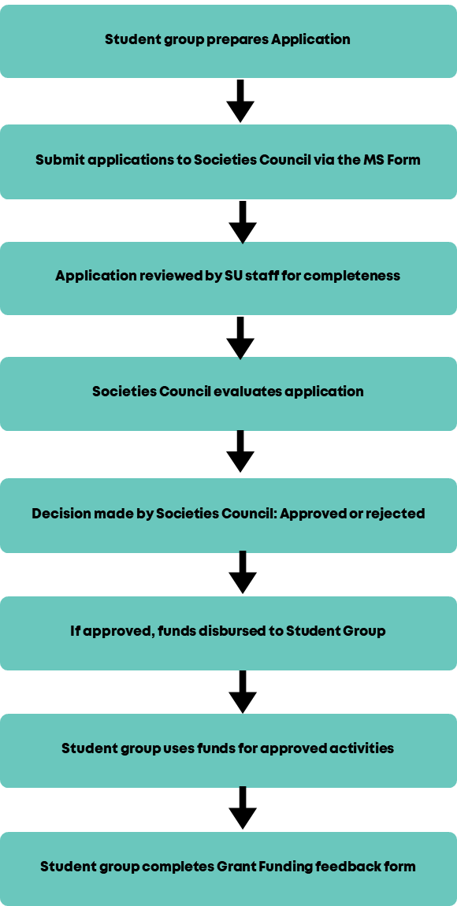

## Societies Council

Societies Council aims to give a platform for the opinions and ideas of Committee Members to support the direction of the Activities & Volunteering Department at the Students’ Union. You can find out more about this on our website [here](https://www.leicesterunion.com/opportunities/societies/councils/).

New Student Group applications are considered at regular meetings and are taken by a majority vote at Societies Council meetings, whereby at least two thirds of the Societies Council must agree. Any conflicts of interest must be declared, and members with conflicted interests will not have the final say on an application.

The Executive Officer team may be required to vote on New Student Group Applications in extenuating circumstances (such as short-notice liberation campaigns or during campus closure periods) in the absence of the Societies Council.

## Available Support – Students’ Union Activities Team

The first avenue of support you will have available is the Activities Team at the Students’ Union and we are available to help you before you submit your application and after you submit your application.

We are also available to support your if your New Student Group application gets approved and can support you with the following things including but not limited to:

* Managing Student Group finances
* Setting up Student Group memberships
* Donating to charity
* Room bookings
* Support with events and campaigns
* Workshops to showcase your committee experience

If you have any queries or feedback regarding New Student Group applications, please email unionactivities@le.ac.uk.

Please also feel free to visit the Students’ Union reception located on the first floor of Percy Gee Building Monday-Friday 10:00AM-16:00PM.

## Available Support – Academic Reps and School Departments

If you would like to start a student group but don’t know any other students that can help you run the Student Group, we recommend that you get in touch with [your Academic Rep](https://www.leicesterunion.com/voice/academic-representation/currentreps/) and [school department](https://le.ac.uk/a-z/departments) as they may know another student who is also interested in starting the same Student Group.

If you are an academic-based society and your application gets approved, we highly recommend contacting your Academic Rep as they your Academic Rep may wish to host similar events to yourself and you can support each other with these events. Your Academic Rep can widen the outreach your Student Group has as they may know students who would be interested in joining your Student Group.

If you are an academic-based society and your application gets approved, we also recommend contacting your school department as your school department will have the contacts of a range stakeholders that you may be interested in e.g., industry professionals if you wish to hold a career-related events. Your school department may also be willing to advertise your Student Group events or activities on their social media.

## Additional Information

This policy applies to any current University of Leicester Student that is interested in starting a New Student Group.

Should an application be approved, Student Groups must abide by the [Student Group Constitution,](https://www.leicesterunion.com/opportunities/societies/committeehub/committeeinduction/) Code of Conduct and all other policies at the University of Leicester Students’ Union.

This policy does not form any part of the [Student Group Constitution](https://www.leicesterunion.com/opportunities/societies/committeehub/committeeinduction/) and may be amended at any time. Warning will be given where possible, but is not required.

This policy is in addition to the [Student Group Constitution](https://www.leicesterunion.com/opportunities/societies/committeehub/committeeinduction/) and any other policies and documents held

by the University of Leicester Students’ Union.

## How can we get in touch?

If you have any queries or feedback regarding New Student Group applications, please email [unionactivities@le.ac.uk.](mailto:unionactivities@le.ac.uk)

Please also feel free to visit the Students’ Union reception located on the first floor of Percy Gee Building Monday-Friday 10:00AM-16:00PM.

## Change Log

Created for the 2025-2026 academic year (25/06/2025)