

leicesterunion.com

Student Group Grant Funding 2025/26 Guidelines

Contents
1. Introduction 3
2. Disclaimer 4
3. Equity & Inclusion Aims 4
4. How much can our Student Group apply for? 5
5. What is and isn’t eligible for Grant Funding? 6
6. How do we apply? 9
7. Timeline 10
8. Societies Council 11
9. Appeals Process 11
10. Additional Information 11
11. How can we get in touch? 12
Change Log 12

Introduction

  - Every year, the Students’ Union’s Activities & Volunteering Department has funds available to support affiliated Student Groups in their development, to reach new goals and objectives while considering inclusivity and accessibility. This money is awarded to help subsidise the costs of Student Group opportunities and development.

  - This year we have a total of £25200 available for all Student Groups to apply for in 2026/27.

Term | Amount allocated | Application Timelines
Term 1 | £10500 | September 2026
Term 2 | £10000 | December 2026
Term 3 | £1000 | March 2027

  - You should factor these timeframes into your planning, and make sure you apply well before the deadline. Late applications and retrospective applications (for expenses that have already been paid) will not be considered.
  - It is important that you read through example applications before starting to fill out your own application.
  - Please note that we may require you to attend a meeting to discuss your application before it’s considered by Societies Council. This will help make your application as strong as possible, and maximise your chances of being approved for funding.

- Disclaimer
  - Whilst we endeavour to support student groups to our best ability, please note that an application submitted for Grant Funding does not guarantee Grant Funding will be awarded to the Student Group.

  - If a student group was awarded Grant Funding previously, this does not guarantee that the student group will be awarded Grant Funding again.

  - Student Groups must use the Grant funding for the purpose intended and within the term the application was submitted and granted.

  - No abuse will be tolerated towards Societies Council, staff at the Students’ Union or Executive Officers online or in person related to any decision or process of Grant Funding.

  - Grant Funding applications can only be submitted through the Grant Funding application form. Any other submission that is not the Grant Funding application form will not be accepted.

How much can our Student Group apply for?

  - Affiliated Student Groups can make as many applications as they like throughout the year until they have reached the maximum, they are eligible for. Applications from Team Leicester Clubs are subject to additional guidelines.

  - The maximum total Grant Funding that any one Student Group can receive in the academic year 2026/27 is:
    - £1000 for any student group and Team Leicester Clubs (tier 1-3).
    - £1450 for performance groups and non-Team Leicester sports clubs (except tier 4 TL).

  - We cannot guarantee that we will be able to fund every application, so please make sure you plan accordingly.

  - Current performance and non-Team Leicester sports clubs:

    - Afrodance Collective
    - Asian Dance Society
    - Bhangra Society
    - Big Band
    - Bollywood Dance
    - Brazilian Jiu-Jitsu
    - Chamber Choir
    - Chorus
    - Concert Band
    - Craft Society
    - DanceSport
    - Filmmaking Society
    - Flying Team
    - Gymnastics Society
    - Ice Skating Society
    - Kendo
    - Leicester Glee Club
    - Leicester Karate Club
    - Mixed Martial Arts (MMA)
    - Modern Dance
    - Motorsport and Karting
    - Orchestra
    - Parkrun Society
    - Pole Fitness and Dance
    - Salsa Society
    - STEM Netball
    - The Revival (UoL Gospel Choir)
    - The University of Leicester's Ski and Snowsports Society
    - UOL Barbell
    - We Create

Grant Funding Eligibility

Can Apply For:
Purchasing resources or equipment that is reusable and has longevity, with direct correlation to the student group purpose
For subsidising costs of large impact or one-off opportunities that benefit all members and would otherwise not be accessible to students
For supporting development initiatives that would otherwise not be possible or accessible to students or have a high impact on the student groups development

Cannot Apply For:
Single-use unsustainable purchases or items that cannot be reused
Events/purposes that can otherwise be covered financially by the student group, participants or self-efficient fundraising
Anything that only benefits the committee
Anything that benefits non-UOL students in any capacity
Events/opportunities that have already happened as a reimbursement of costs
To cover debts or overdraft funds in the student groups account
All of the costs to be covered by grant funding, with no evidence of self-efficient funding or student group contributions (without a justifiable reasoning)
Any purposes that occur outside of the term you are applying in. You can only use the funding within the term that it has been approved
Anything that exceeds the £1000/£1450 maximum that you can ask for
For purchasing alcoholic products or for the purpose of gambling
For charity donations or fundraising towards charity/charities (due to UK Charity Law)
Groups with a membership price below £5

PLEASE NOTE:
  - The above lists are guidelines only, and are not exhaustive.
  - All applications are considered on a case-by-case basis and the Council has the discretion to compare and decide which applications are more impactful.
  - Team Leicester Clubs will not be eligible to receive Grant Funding for any expenses related to BUCS. The funding received from Team Leicester (Sport and Active Life) will be taken into account when your Grant Funding Application is considered.
  - LUSUMA sub groups are not eligible for grant funding because they receive funding from LUSUMA with the exception of LUSUMA submitting the application on their behalf with clear reasons on why LUSUMA is not funding that activity or project.
  - If you’re unsure whether what you’re applying for will be eligible for funding, please contact unionactivities@le.ac.uk in advance so that we can advise and support your application.

How do we apply?

  - As funding is limited every year, it is important that you discuss your plans as a Committee before filling out the application form. As the main budget holder, your Student Group’s Treasurer will need to sign off on the application. We cannot guarantee that we will be able to fund every application, so please make sure you plan accordingly.

  - We might ask you for further clarification and adjustments, or require you to attend a meeting to discuss your application before it’s considered by the Societies Council (see section 8). This will help make your application as strong as possible, and maximise your chances of being approved for funding. You should apply well in advance of the deadline to allow plenty of time for changes to be made.

How to make a strong application:
    - Clearly explain the benefits to current University of Leicester students.
    - Link to the aims and objectives of your Student Group as stated in your Constitution.
    - Be well-researched, with clear breakdown of all expenditures and incomes that are in directly related to what you need funding for.
    - Include a full plan of your Student Group’s budget.
    - Your Student Group should contribute a reasonable percentage of the overall costs of the application (through ticket sales, membership fees, club fundraising, sponsorships, etc.).
    - Clearly explain how the Grant Funding would help you foster an environment of inclusion and accessibility in your Student Group, for example, by supporting students from liberation and/or marginalised backgrounds.
    - Be submitted well in advance of the deadline for when the money will be spent.
    - Clearly explain how you will include the Students’ Union logo in your marketing / promotion / mention the Grant Funding support on your social media. This will encourage more Student Groups to apply for Grant Funding and increase awareness of the scheme.

Priority will be given to Student Groups who:
    - Demonstrate a well-run Committee with good organisation and communication with the Students’ Union’s Activities & Volunteering Team. For example, by attending Development Meetings and submitting documentation on time.
    - Demonstrate sustained commitment to improving accessibility and inclusion in their Student Group.
    - Have completed all of their mandatory Affiliation Documents and Committee Training.
    - Have completed the mandatory Feedback Form if they have previously benefitted from Grant Funding.
    - Get in touch with us well in advance of the deadline with any queries, concerns, or for help with their application.

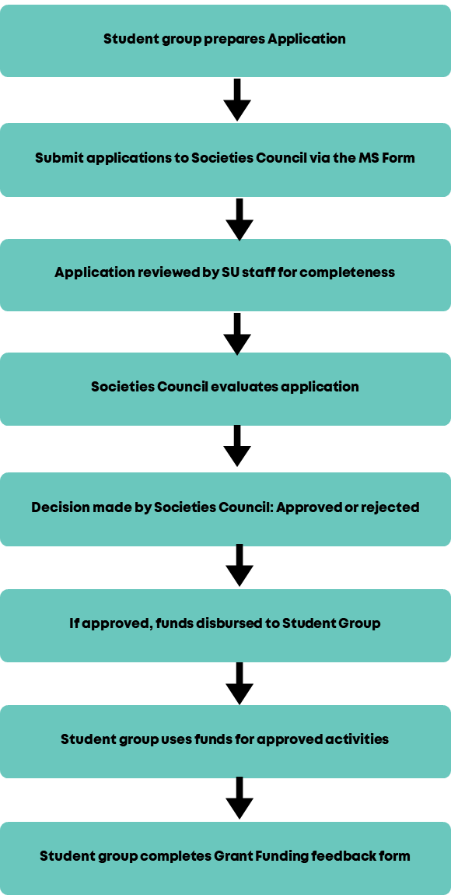

Societies Council

  - Societies Council aims to give a platform for the opinions and ideas of Committee Members to support the direction of the Activities & Volunteering Department at the Students’ Union. You can find out more about this on our website here.
  - Grant Funding Applications are considered at Societies Council meetings and are taken by a majority vote, whereby at least two thirds of the Societies Council must agree. Any conflicts of interest must be declared, and members with conflicted interests will not have the final say on an application.
  - The Executive Officer team may be required to vote on Grant Funding Applications in extenuating circumstances (such as short-notice liberation campaigns or during campus closure periods) in the absence of the Societies Council.

Appeals Process

  - If your Grant Funding Application is not successful, you can appeal to have it reconsidered. You will be given reasons why your application was unsuccessful and you should address these points in your appeal. Appeals should be submitted to unionactivities@le.ac.uk within 7 calendar days of the date that the application outcome is emailed to the Student Group. Appeals will be considered by Students’ Union Executive Officers who do not sit on Societies’ Council.
  - The outcome of the appeal will be sent to the Student Group within 5 working days of their appeal submission. The Executive Officers’ decision is final. If appeal is rejected, repeat applications for the same thing will not be considered.

Additional Information

  - This policy applies to all affiliated Student Groups (including Team Leicester) that fall under the jurisdiction of the Activities & Volunteering Department at the University of Leicester Students’ Union.

  - Student Groups must abide by the Student Group Constitution, Code of Conduct and all other policies to remain eligible for Grant Funding.

  - This policy does not form any part of the Student Group Constitution and may be amended at any time. Warning will be given where possible, but is not required.

  - This policy is in addition to the Student Group Constitution and any other policies and documents held by the University of Leicester Students’ Union.

How can we get in touch?
If you have any queries or feedback regarding Grant Funding, please email unionactivities@le.ac.uk. You can also receive Student Group financial support and help with completing an application by contacting unionactivities@le.ac.uk.

Change Log
Updated for new academic year (19/09/2023)
Updated for 2025-2026 academic year (09/06/2025)
Updated for 2026/27 academic year (28/04/2026)

