How to start a New Student Group (Society/Club) guide 25.26

Contents
1. Introduction 3
2. Disclaimer 3
3. New Student Group Criteria 4
4. How to apply 4
5. Timeline 5
6. Societies Council 6
7. Additional Information 6
8. How can we get in touch? 6
Change Log 6

Introduction

A Student Group, which is also referred to as a Society or Club, is a group where students can meet and have the opportunity to complete activities and attend events based on hobbies, sports, academic courses, community action, faith, nationality and culture, music, performances and many more. We will be using the term ‘Student Group’ throughout this handbook. A student may find that there is not a current student group that exists in their interested area so they may wish to start a New Student Group.

A New Student Group can be a Student Group that has never existed before or re-starting a Student Group that hasn’t been active in the current academic year. You may hear the phrase ‘adopting a Student Group’ which is the same as re-starting a Student Group.

The students who run and organise a Student Group are referred to as the Committee of that Student Group. A Student Group must have the three core positions filled to be officially affiliated with the University of Leicester Students’ Union. These three core positions are President, Treasurer and Events and Socials Coordinator. The three core positions must be fulfilled by three different students who currently attend the University of Leicester. You can also add non-core positions to your Student Group such as Secretary if you wish to do so.

It is important that you read through this handbook carefully, and get in touch if you have any questions. You should also read through the example applications before starting to fill out your own application. Please note that we may require you to attend a meeting to discuss your application before it’s considered by Societies Council. This will help make your application as strong as possible, and maximise the chances of your New Student Group application being approved.

Disclaimer

Whilst we endeavour to support students to start a New Student Group, please note that an application submitted to start a New Student Group does not guarantee with certainty that the application will be approved.

If a similar New Student Group application was approved before in the past; this does not guarantee your application will be approved.

Zero abuse will be tolerated towards Societies Council, staff at the Students’ Union or Executive Officers online or in person related to any decision or process of New Student Group applications.

New Student Group applications can only be submitted through the New Student Group application form. Any other submission that is not the New Student Group application form will not be accepted.

New Student Group Criteria

Unique: Please ensure that your Student Group is different to the current existing Student Groups. You can find the full list of existing groups here. Groups that are too similar to others or one that could fit underneath an existing group will not be approved. Below is a breakdown of what that requirement means:
- Purpose and Aims - Your group's core purpose should not duplicate the mission, theme, or objectives of an existing Student Group. Clearly state what specific need, interest, or community your group will meet that is not currently addressed.
- Activities and Events - Describe how your planned activities differ from what similar groups already offer. If any activities overlap, you must show how your approach, focus, or format is fundamentally different.
- Target Audience - If your group appeals to a particular demographic or interest community, explain how this differs from existing groups with similar audiences.
- Why does this matter? Groups that are too similar will not be approved, as duplication can dilute membership, resources, and student engagement. Your application should demonstrate a justified and sustainable gap within the current Student Group landscape.
Feasibility: Running a Student Group offers valuable opportunities to gain leadership, organisational, and teamwork skills. However, it also comes with ongoing responsibilities. Before applying, ensure that:
- Time Commitment - You can realistically manage the additional time commitment alongside your academic and personal responsibilities.
- Delegation - Your committee is willing to work collaboratively, communicate regularly, and share tasks fairly.
- Workload - You have considered the planning required for events, finances, administration, and member engagement.
Any proposed groups must have the following core roles filled by different and current UOL students:
- President
- Treasurer
- Events and Socials Coordinator
Please check the role descriptions linked here before confirming roles.

Before you submit your application, please also consider:
- Does your Student Group have any items/equipment that needs to be stored? If yes, where will this be stored?
- What are the ongoing expenses of running your Student Group?
- What regular events/activities will you run?
- Will you have any special one-off events?
- How will your committee communicate with each other?

How to apply

Once you have read this handbook, please fill out and submit the application form.

Please answer the questions to the best of your ability. Once you have submitted your application form, it will be reviewed by the Activities Team. The Activities Team, will either approve the new student group application, or refer it to the Societies Council. The council will then decide whether to approve, refer or reject it. Referrals mean that the council may have further questions about the application and then based on the answer you give to these questions, the council will either approve or reject the request.

We might ask you for further clarification and adjustments. This helps make your application as strong as possible, and maximise your chances of being approved. You should apply well in advance of the deadline to allow plenty of time for changes to be made.

Timeline

Please see below the dates and deadlines for the remainder of the 25/26 academic year:
Applications Open: | Application Close: | Hear Back By:
18th December @9am | 12th January @ 9am | 16th January @ 4pm
30th March @ 9am | 27th April @ 9am | 30th April @ 4pm

Below is a diagram of the New Student Group Application Process:

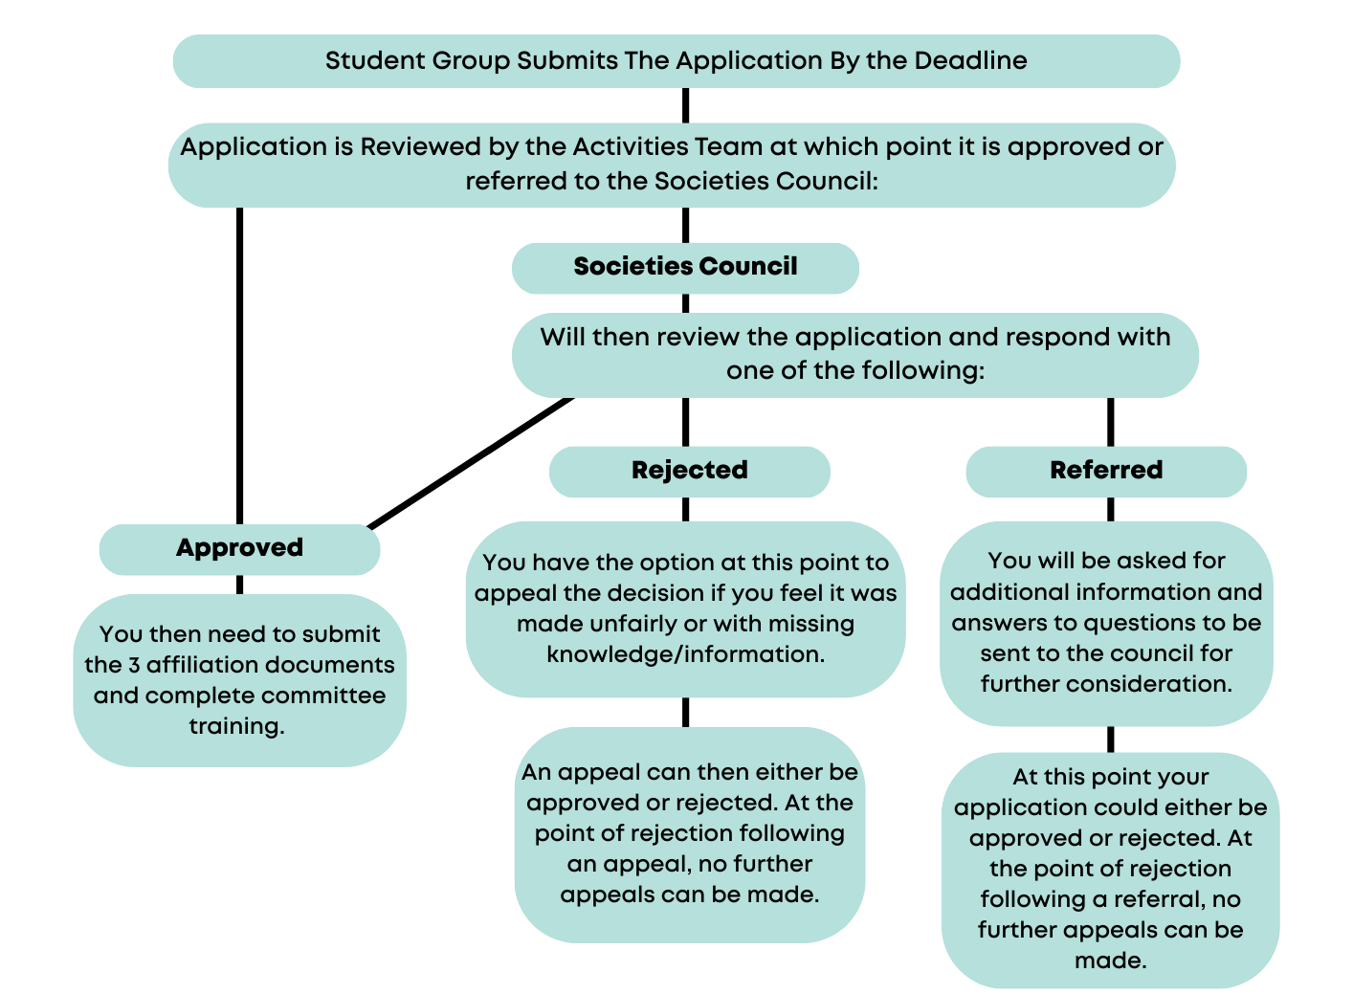

Societies Council

Societies Council aims to give a platform for the opinions and ideas of Committee Members to support the direction of the Activities & Volunteering Department at the Students’ Union. You can find out more about this on our website here.

New Student Group applications are considered at regular meetings and are taken by a majority vote at Societies Council meetings, whereby at least two thirds of the Societies Council must agree. Any conflicts of interest must be declared, and members with conflicted interests will not have the final say on an application.

The Executive Officer team may be required to vote on New Student Group Applications in extenuating circumstances (such as short-notice liberation campaigns or during campus closure periods) in the absence of the Societies Council.

Additional Information
This policy applies to any current University of Leicester Student that is interested in starting a New Student Group.

Should an application be approved, Student Groups must abide by the Student Group Constitution, Code of Conduct and all other policies at the University of Leicester Students’ Union.

This policy does not form any part of the Student Group Constitution and may be amended at any time. Warning will be given where possible, but is not required.

This policy is in addition to the Student Group Constitution and any other policies and documents held
by the University of Leicester Students’ Union.

How can we get in touch?
If you have any queries or feedback regarding New Student Group applications, please email unionactivities@le.ac.uk.
Please also feel free to visit the Students’ Union reception located on the first floor of Percy Gee Building Monday-Friday 10:00AM-16:00PM.

Change Log
Updated on the 16th December 2025 for the 25/26 academic year.
Updated on the 11th February 2026 for the change of the core positions from Wellbeing and Inclusion Ambassador to Events and Socials Coordinator.

